Assignment 1a

Matthijs Brouns 1505157  
Hélène van Heijningen 4076850

This document will describe the system elements and boundaries as identified in the Kirkwood water crisis system.

The following systems have been identified:

* Population System
* Infrastructure System
* Maintenance staff system
* Municipal funds system

There are several interfaces between these systems. These are:

* The maintenance of infrastructure is limited by maintenance staff availability and municipal funds availability.
* The building of new infrastructure or restoring aged infrastructure is limited by maintenance staff and municipal funds availability.
* The need for new infrastructure is determined by the discrepancy between maximum infrastructure capacity and total population demand.
* The productivity of the technical staff is influenced by their work pressure.

# Experimental setup

The base unit of the model is in years. The system is observed over a period of 50 years, since this allows for several cycles of infrastructure ageing and rebuilding. As a solver method euler is chosen. Euler is chosen because there are several discrete changes in the system which runge-kutta can't solve. The time step needs to be ranging from 0.5 to 0.1 times the smallest time-constraint in the system. Currently in the model this is 1/10th of a year for planning to address discrepancies in infrastructure. Therefore the time-step of 0.015 is chosen. When testing with this timestap we have noticed no numerical errors, therefore, it is considered to be sufficiently small.

# Maintenance staff system

The staff system is made up of three parts. The first describes the hiring of staff and the time the staff remains in service.

The second part determines the production rate per staff member. Staff member productivity is dependent on the staff occupancy (which is on its turn dependent on the required production coming from the infrastructure system and the available staff). We assumed that when staff occupancy is very low, the available staff will have a 50% increased productivity. However, as staff occupancy increases this productivity gradually drops to a minimum of 10% productivity when Kirkwood is 5 times understaffed.

The third part of the staff system determines the distribution of attention of staff members. Distribution of water through tankers in the case of a water crisis always takes priority. If after that enough staff members are available for all work, no distribution is made. However, when staff capacity is limited 25% of staff attention is given to maintenance activities, and 75% to refurbishing and planning activities. The refurbishing and planning activities are divided pro ratio.

# Municipal funds system

The funding system consists of an inflow of cash and an outflow of cash.

Municipal revenue regarding the water system comes from two sources: an annual governmental bail-out and income from the delivered water. The bail-out consists of a 150 kZAR / year fund to help the municipality with water infrastructure. This bail-out is assumed to not arrive in a single pulse, but rather gradually over the year. Not all delivered water is billable. 75% of urban water and 40% of household water usage is billable and paid on average. According to the background reading, 40% of the municipal income is spent on maintenance. Since only maintenance expenditures are modelled, the income flow in the model is reduced by 60%.

The outflow of cash is determined by the maintenance cost of the infrastructure. Maintenance cost of infrastructure is set at 2.5 kZAR per ML of infrastructure capacity per year.

Since the funds system only constraints the maintenance of infrastructure (and not the building and planning of new infrastructure), a funding crisis will not affect the construction of new infrastructure.

# Crisis system

The crisis system describes the two possible water crises which can occur in the Kirkwood area.   
The first water crisis is when there is general unrest or dissatisfaction regarding the delivery of water to residents or other urban water users. Since no information regarding this dissatisfaction was available we modelled it as follows:

Dissatisfaction depends on the delivery rate of water, and the period for which there was a delivery discrepancy. The delivery rate is defined as the portion of the water demand which can be met based on the infrastructure capacity. The unrest is then defined as the discrepancy rate times the time for which this discrepancy has been going on. The graphical output of this system is shown in figure 1.

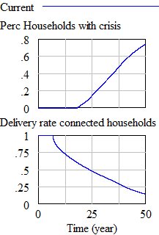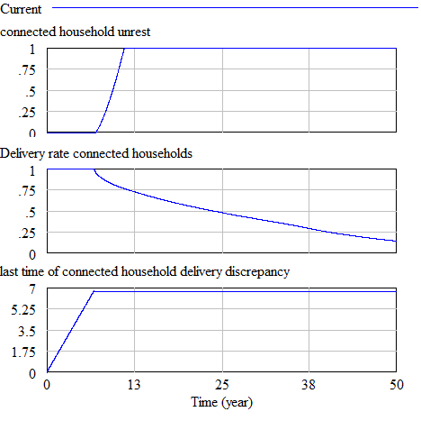

**Figure 1: Water delivery dissatisfaction Figure 2: Water supply crisis**

The second water crisis which can occur is when there is a chance that the basic water limit for survival cannot be met. This water limit is set to a minimum of 10 liter / person / day. We assumed that water will not be distributed evenly among all households. Instead, we assume that when only 50% of total water demand can be met, already 10% of the households will be facing water shortages large enough for additional water supply through tankers to be necessary (see figure 2). This is modelled using a LOOKUP function. Each tanker is assumed to require the attention of 1 staff member in order to distribute the water.

# **Population** System

The population system is mostly used as input for the rest of the model. Its main purpose is to determine the maximum water demand at a certain point in time. The information regarding the population system from the background literature proved insufficient to accurately model the behaviour as described during the lecture. The background reading described a system which would have exponential growth, while the lecture described constrained growth.

In order to achieve the behaviour as described in the lecture two target population values for the unconnected and connected households in Kirkwood are added. Due to this addition it must be noted that the population system is not valid as a system which can be experimented on. It should only be used as an input for the rest of the model.

# Infrastructure System

The infrastructure system describes the commissioning, decommissioning and maintenance of the water supply system in the Kirkwood area.

Several assumptions needed to be made due to gaps in the background reading. These assumptions are described in this section.

Effect of maintenance on ageing time  
In the background reading it was described that at 8% maintenance per year the average aging time of infrastructure is 30 years. We assumed that when there is 0% of the infrastructure is maintained per year, the average aging time will become 15 years. If all infrastructure is maintained each year, the average infrastructure aging time will increase by 10 years.

Effect of maintenance on leakage  
In the background reading it was described that there is an average leakage of 30% due to bad maintenance. We assumed that if maintenance levels drop below the 8% indicated in the reading, leakages will rise to 50%. However, if infrastructure maintenance is increased the leakages will gradually drop to 0%.

Effect of capacity pushing on ageing time  
The background reading described that pushing the infrastructure can drastically decrease the lifespan of infrastructure. We assumed that at the maximum pushing of infrastructure of 30% the lifespan of infrastructure is decreased by 10 years.

Required staff for constructing and planning infrastructure  
Constructing new water infrastructure is mostly done by staff on a governmental level rather than staff on the municipal level. However, some supervision is still required by municipal staff. We assume that municipal staff is required for about 10% of the construction and planning activities. The rest is carried out by governmental staff which is out of scope of this model. Therefore, governmental staff is assumed to be always available.

# Model behaviour

In this short chapter the behaviour of the model is shown in the base case scenario as well as a scenario where the hiring of staff is increased from 1 staff per 2 years to 5 staff per 2 years.

## Base case

In the base case scenario the model shows the model starts with a infrastructure surplus which quickly turns into a growing shortage of infrastructure mainly due to the decrease of available staff. This means that in time the practical infrastructure capacity will decline as maintenance decreases to almost zero. Because not enough water is being supplied to the population of Kirkwood, tankers are put in place to distribute water to make sure the population will get enough water to survive. The base case shows the system is in a deep crisis which seems to get only worse in the future.

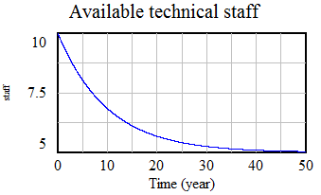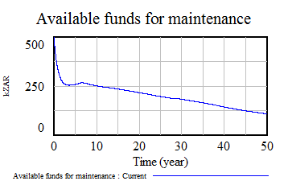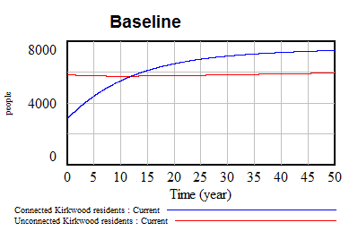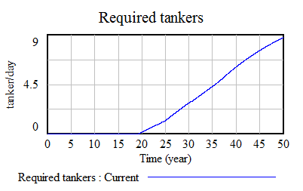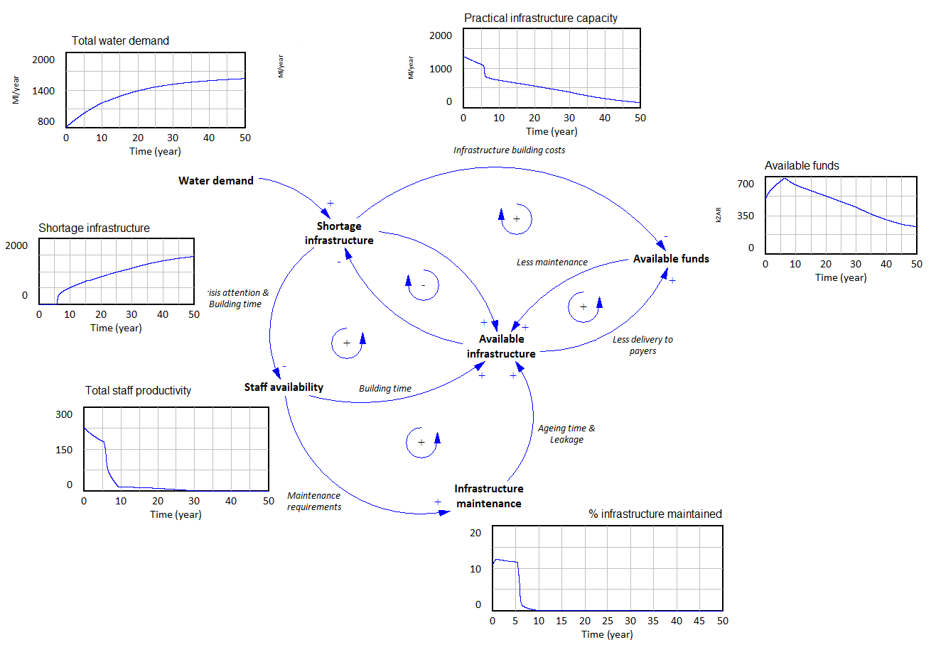

## Figure 3: Baseline system behaviour

## Behaviour after staff increase policy

Because the base line behaviour shows obvious signs of staff shortages, we have experimented with a higher hiring rate of staff (from 1 per 2 years to 5 per 2 years). The results of this experiment are shown in figure 4. This system shows a much smaller infrastructure shortage and this shortage also gets solved over time. No water crisis occurs in this experiment, which is why no tankers have to be used.

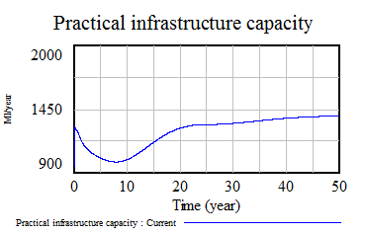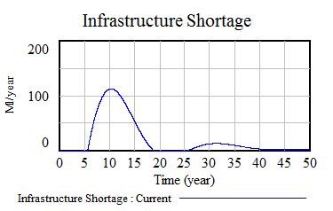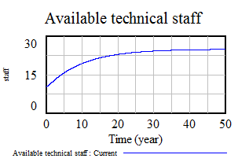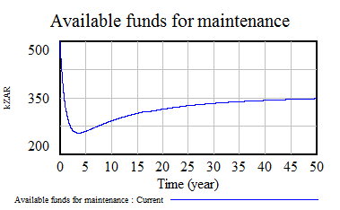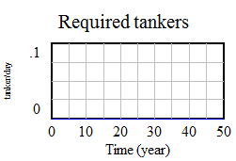

**Figure 4: increased staff hiring results**